|  |
| --- |
| C:\Users\zida\Desktop\Assignment01\Assignment01\assets\images\logo.png |
| Zida’s Home Page |
| Comp 308 - 063 |
| Assignment 01- Personal Portfolio Site |
| **Zida Bi** |
| **300716389** |

|  |
| --- |
|  |

Table of Contents

**Website Description3**

**Navigation Bar4**

Medium and lower sizes4

Big and upper sizes5

**Colors Section6**

**Typography7**

**Wireframes**8

**Branding**11

Website Description

This is my personal portfolio site, which include 5 pages. The pages are, index page, projects page, services page, about me page and contact me page.

My index page has a brief view for people of my personal tagline and a slider show for my projects.

Projects page has the details of my three projects shown in the slider.

Services page contain the extensive statement of my personal tagline.

About me page contains my personal information such as co-op experience and personal description.

Contact me page has my personal contact information and social network links.Navigation Bar

Medium and lower sizes:

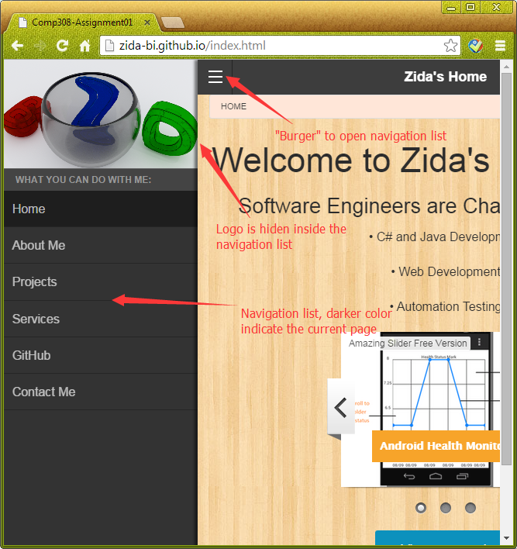

Big and upper sizes:

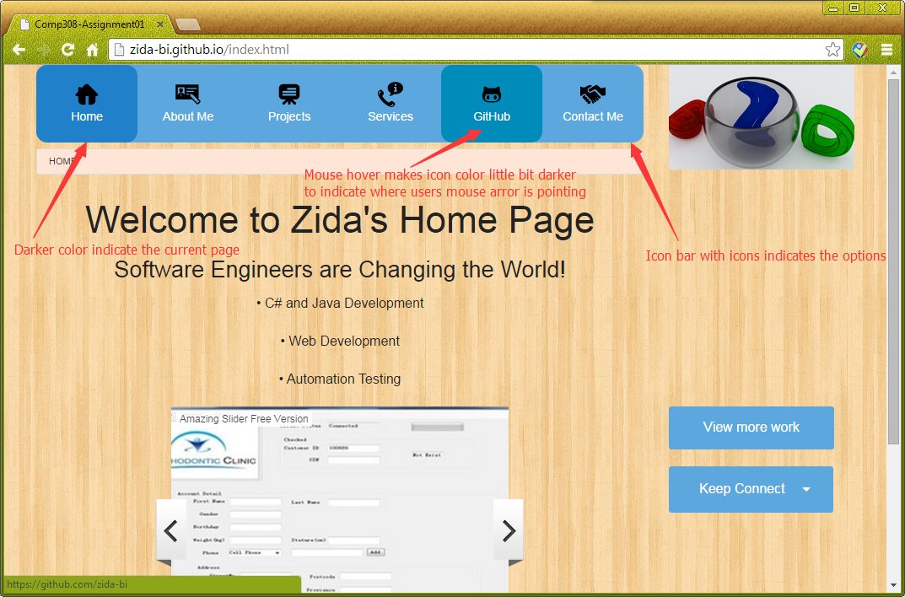Colors Section

|  |  |  |
| --- | --- | --- |
| **Location** | **Swatches** | **Hexadecimal Values** |
| **Icon Bar(Indicating Current Page)** |  | **2081ca** |
| **Off Canvas Tab Bar(Indicating current page in small size)** |  | **1e1e1e** |
| **Icon Bar** |  | **5BA7DE** |
| **View More Work Button** |  | **5BA7DE** |
| **Social Network Dropdown Button(Large Size Home page)** |  | **5BA7DE** |
| **Bread Navigation Bar** |  | **FFE5D6** |

Typography

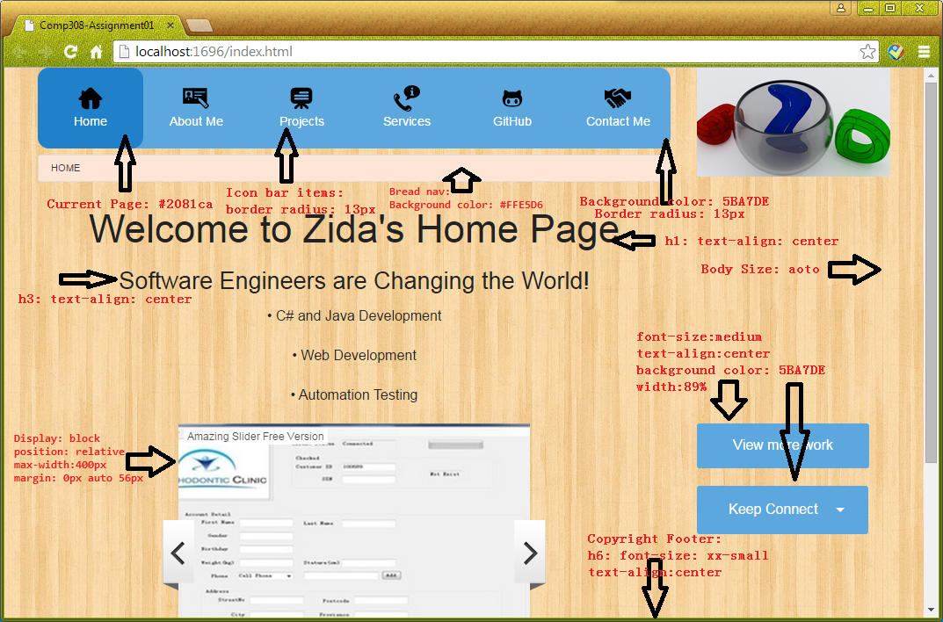

|  |  |  |
| --- | --- | --- |
| Fonts: | Sizes: | Colors: |
| Default | Auto | #2081CA |
|  | medium | #FFE5D6 |
|  | xx-small | #5BA7DE |

Wireframes

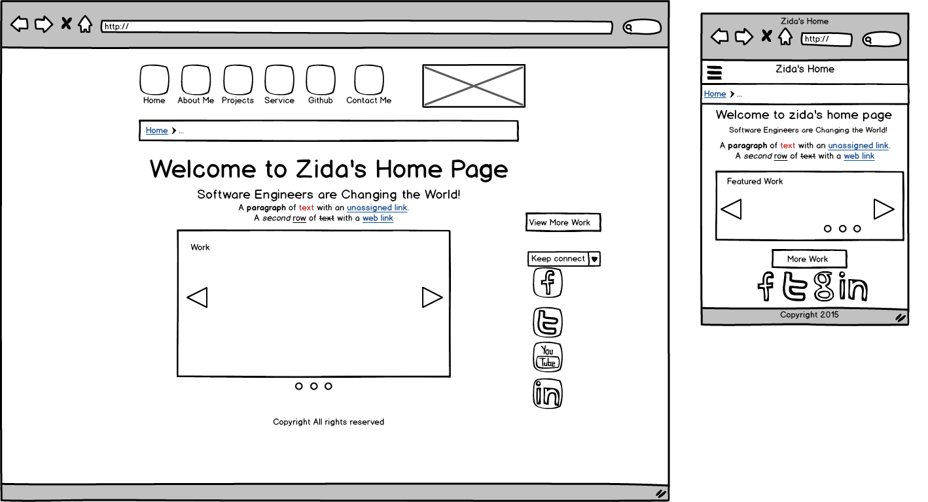

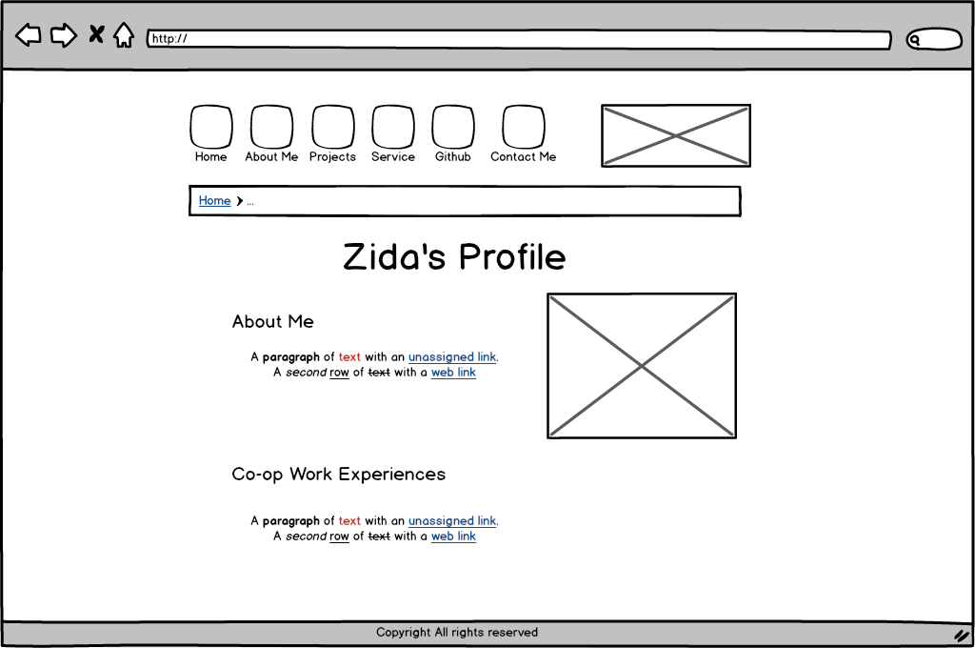

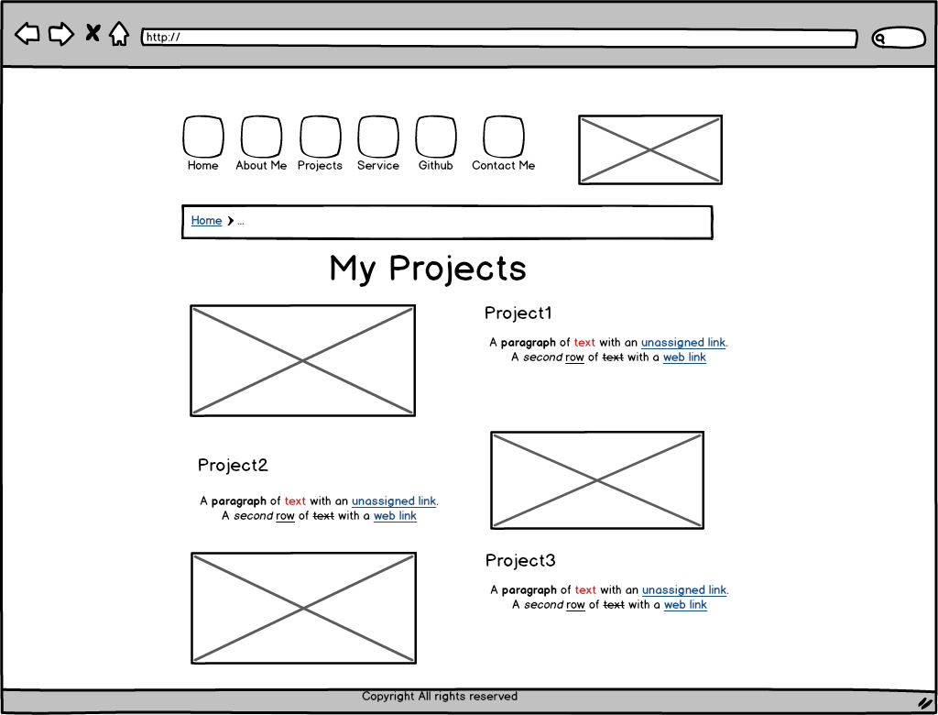

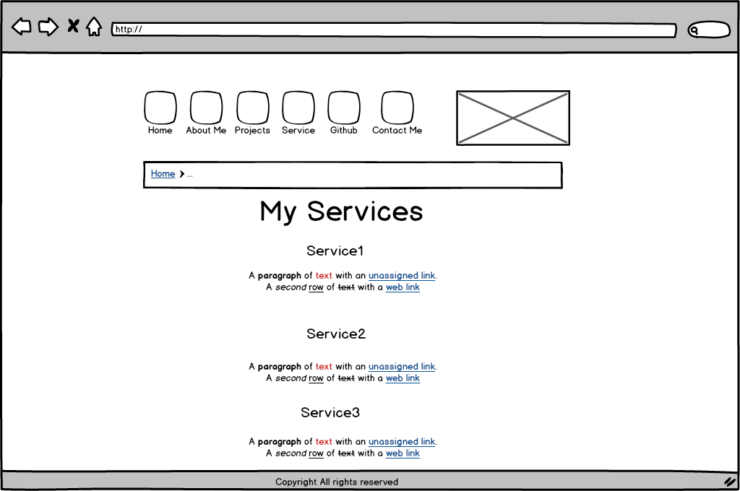

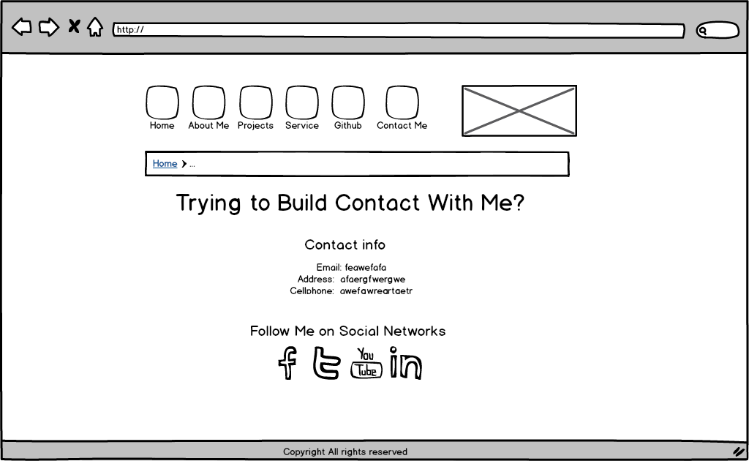

Branding

Logo:

I used tutorials of Blender in youtube as the example of my logo.

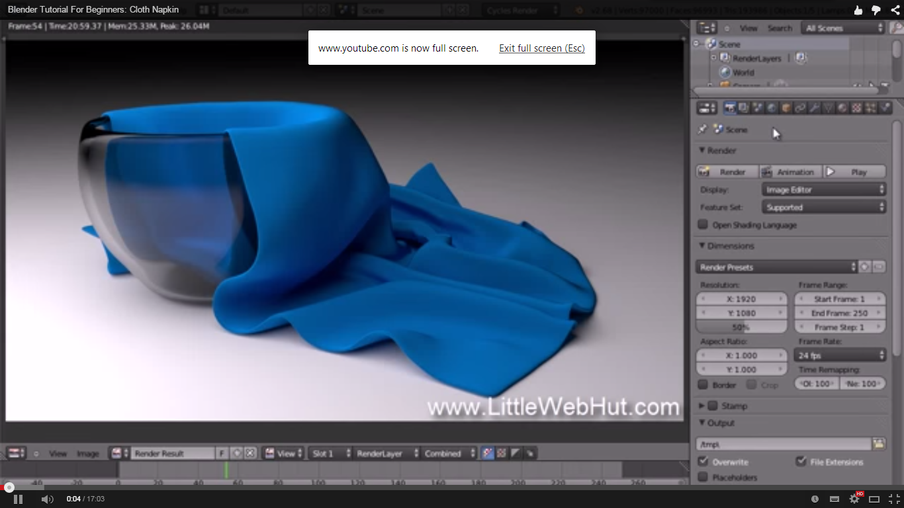

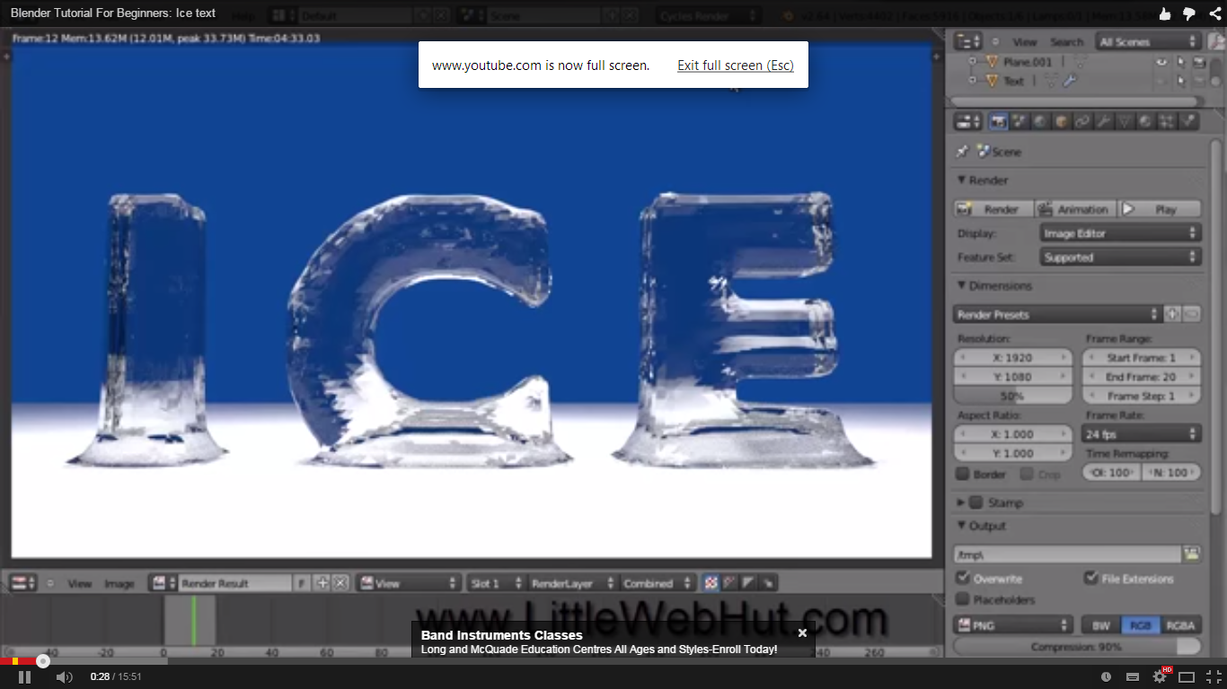

Site Pages:

All site pages are using Foundation framework.

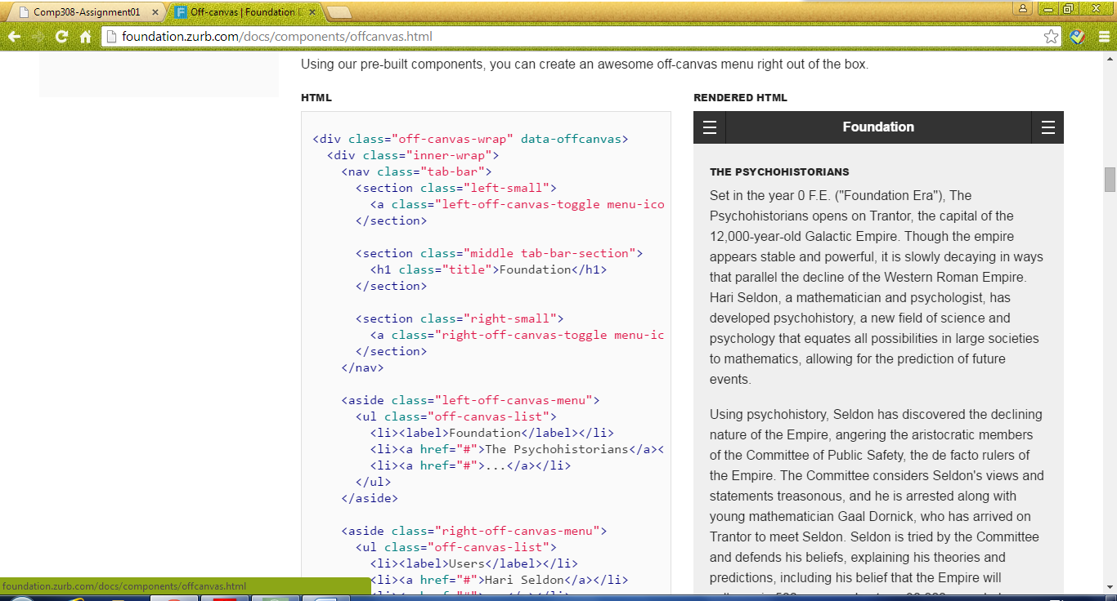

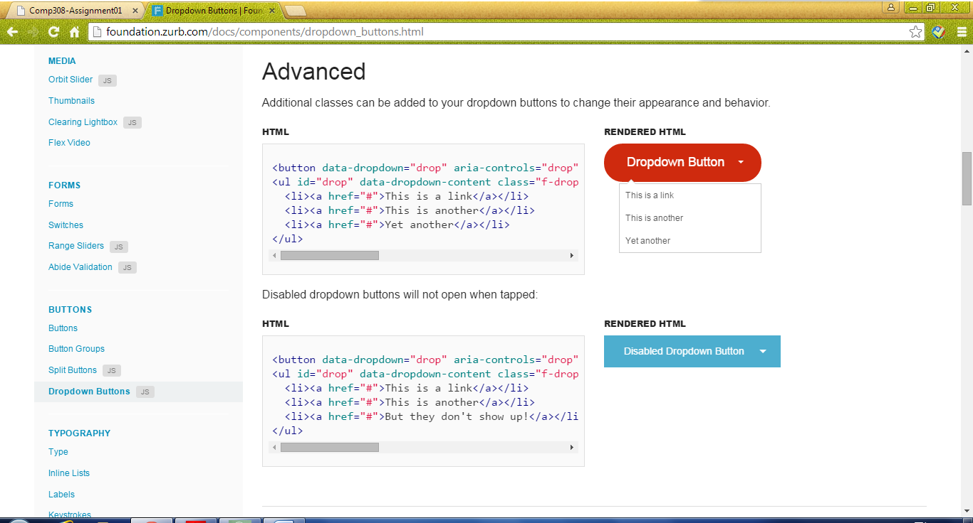

Slider:

Using Amazing Slider as my slide framework

